

**Project Report: COVID-19 Data Analysis Using SQL and Power BI**

**Project Objective**

The goal of this project is to perform exploratory data analysis (EDA) and create an interactive dashboard for COVID-19 data (2020-2023) using Microsoft SQL Server and Power BI. The analysis focuses on vaccinations, demographic impact, mortality rates, and comorbidities to provide insights into the global effects of the pandemic.

**Tools and Technologies**

* **Database**: Microsoft SQL Server
* **Visualization**: Power BI
* **Data Modeling**: Star Schema with Fact and Dimension Tables
* **Data Sources**: COVID-19 case, vaccination, and demographic datasets

**Data Model**

The data model follows a structured approach:

* **Fact Tables**:
  + COVID-19 Cases (cd23)
  + Vaccination Data (cv23)
* **Dimension Tables**:
  + Dates (dates)
  + Locations and Population (pk_location_and_population)
  + Continents (continents)
  + Miscellaneous Attributes (cv23_misalanaceous)
* Relationships are set using unique keys (iso_code, location, and date).

(Refer to the attached data model image for detailed relationships.)

**SQL-Based Exploratory Data Analysis**

Key questions addressed:

1. **First Vaccination Drive Conducted By**: Identified the first country to start the vaccination campaign using SQL queries.





1. **Mortality Rate**: Calculated mortality rate as a ratio of deaths to cases.



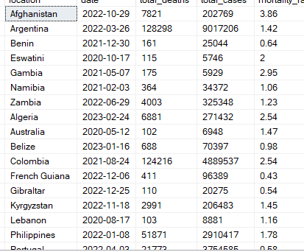

* + **Reaching Milestones in Vaccination**:
  + India's milestone dates for 25%, 50%, and 75% vaccination coverage.











* + Global milestones for vaccination rates.







1. **Weekly Average of Cases and Deaths**: Used rolling 7-day averages.



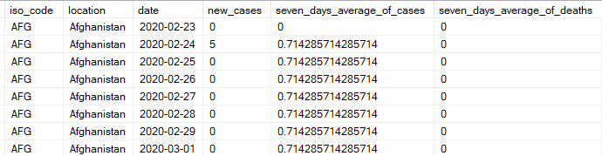

1. **Countries with Case and Vaccination Data Available**: Filtered for countries with complete datasets.





1. **Total Vaccination Per Capita for India**: Calculated as vaccinations per million population.

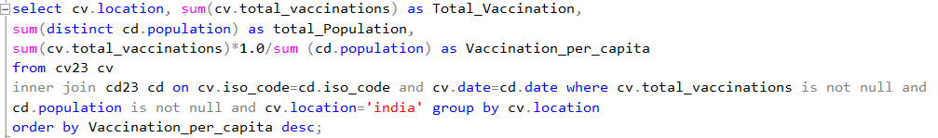



**Power BI Dashboards**

**1. COVID-19 Analysis Dashboard**

* Global vaccination count: 10.84 billion doses.
* Total cases: 763.13 million.
* Total deaths: 7 million.
* Mortality rate: 0.90%.
* Key visualizations:
  + Global map with affected regions.
  + KPIs for vaccinations, cases, and deaths.

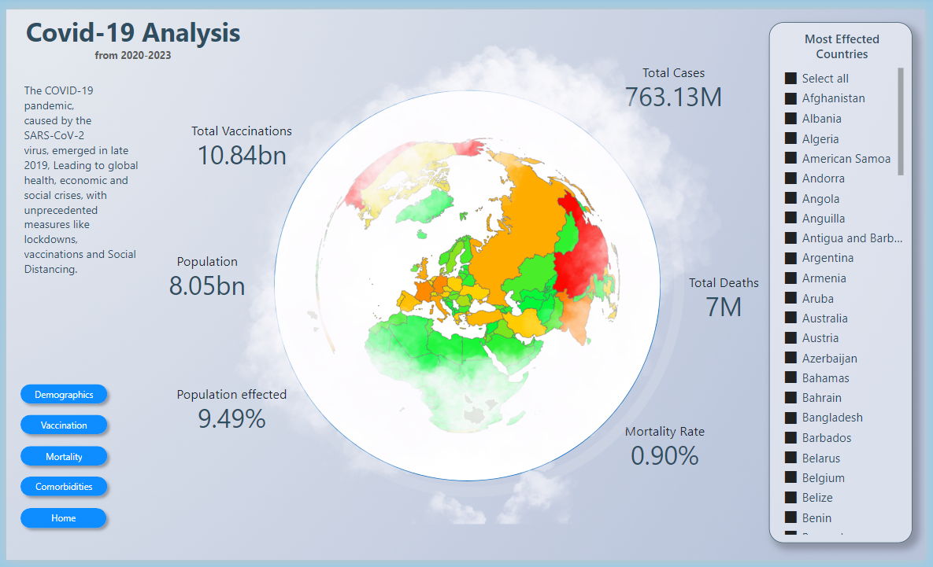

**2. Demographic Analysis**

* Relationship between age groups and mortality rates.
* Scatter plot for population density vs. cases per million.
* Demographic breakdown by continent

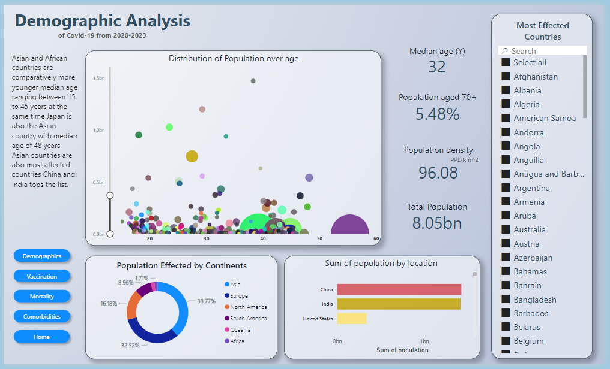.

**3. Vaccinations Analysis**

* Daily vaccination trends.
* Milestone achievements by country.

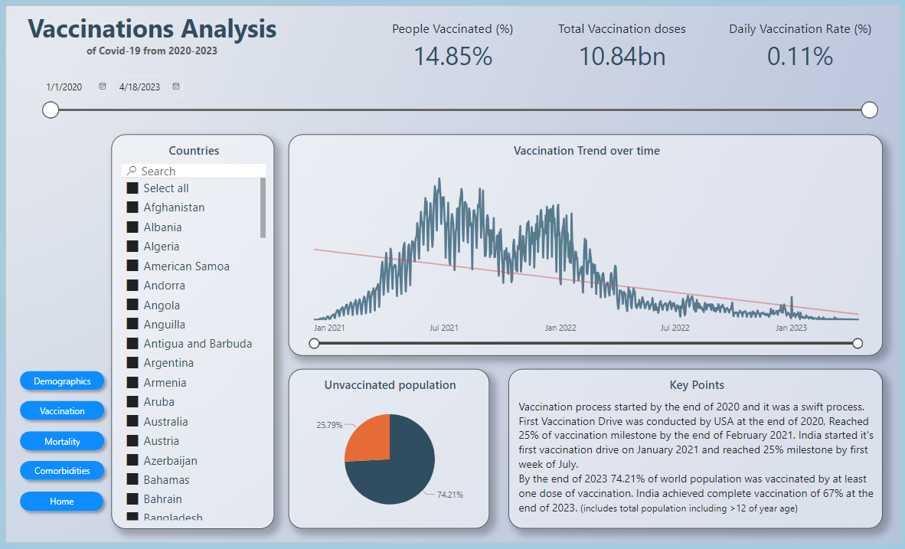

**4. Mortality Analysis**

* Geographic distribution of deaths.
* 857.61 Death reported over every 1 million of population.

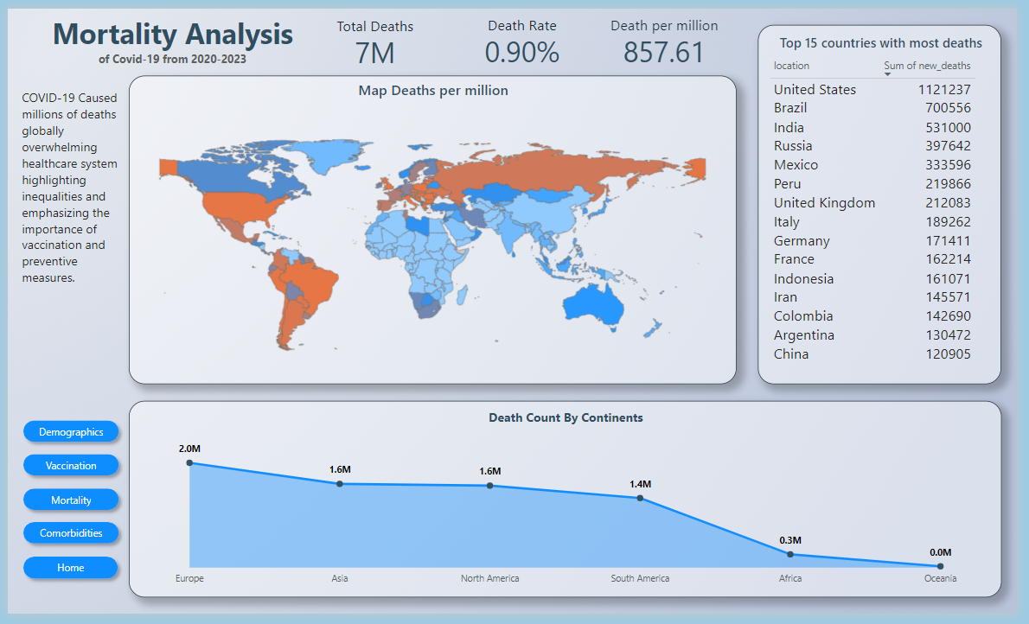

**5. Comorbidities Analysis**

* Cardiovascular death rate: 0.75%.
* Diabetes prevalence: 0.03%.
* Smokers percentage: 0.09%.
* Scatter plot for comorbidities vs. mortality rates.

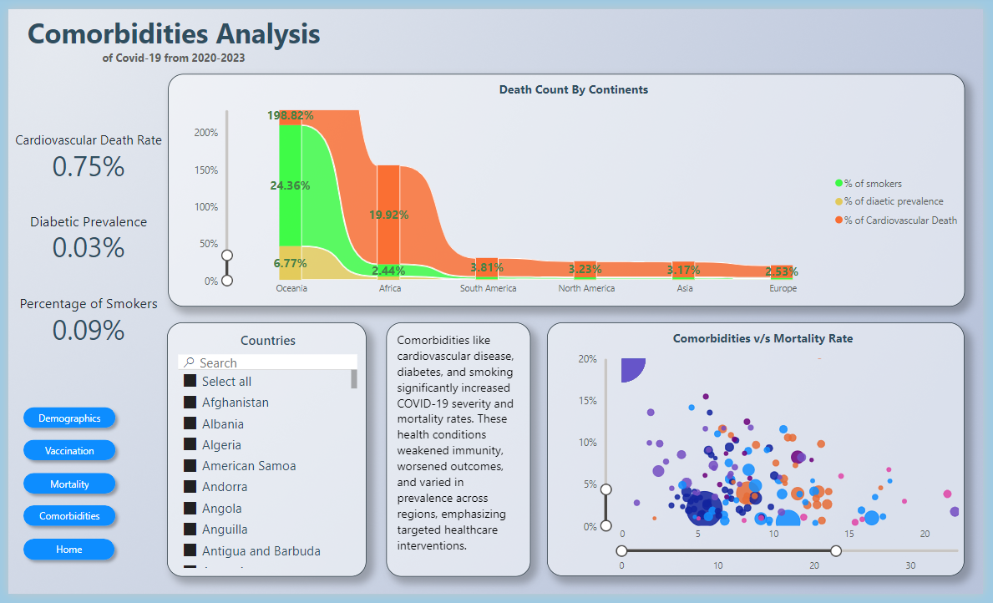

**Insights Gained**

* **Vaccination Impact**: Countries with higher vaccination rates showed lower mortality rates.
* **Global Trends**: Europe, Asis and North America had the highest mortality rates.
* **Comorbidities**: Cardiovascular diseases and diabetes significantly influenced mortality rates.

**Conclusion**

This project highlights the power of combining SQL and Power BI for robust data analysis and visualization. It provides actionable insights into the COVID-19 pandemic, emphasizing vaccination efforts and their global impact.

**Future Enhancements**

* Integrate real-time data updates.
* Include machine learning models for predictive analysis of future pandemics.
* Add sentiment analysis based on global COVID-related news data.

----------------------END-----------------------